**TEACHING DOSSIER**

Philemon Tsang

PhD, Health and Rehabilitation Science

University of Western Ontario

April 2020

**CONTENTS**

**1.** **Brief Biography** 3

**2.** **Teaching Philosophy** 3

**3.** **Teaching Experiences** 5

Centennial College: Math and Science Tutor (Fall 2009) 7

**4.** **Evidence of Teaching Effectiveness** 8

Formal Evaluations: 8

Informal Student Evaluations: 9

**5.** **Course Development** 10

Course Design and Innovation 10

**6.** **Professional Development** 11

# **Brief Biography**

My journey as a teacher began as a University of Waterloo co-op student. My co-op job was tutoring mathematics and science. To further develop my teaching skills, I also completed a co-op education placement at the Toronto District School Board working with Grade 5 and 6 students in an outdoor education setting. During my Master of Science (Kinesiology) at McMaster University, I held a variety of teaching roles including a Teaching Assistant and laboratory mentor. As a teaching assistant at McMaster University, neurophysiology and motor control were the major focus of my teaching. During my PhD program, I was also involved with teaching neuromusculoskeletal physical therapy and clinical education as a limited duties instructor (clinical associate). My research and education background in kinesiology has allowed me to relate orthopedic physical therapy to the foundations of physiology, anatomy, and the social sciences in clinical practice. As outlined in this dossier, I am passionate about student empowerment, pedagogy/andragogy, and teaching and I look forward to continually seek opportunities to further develop my skills as an educator.

# **Teaching Philosophy**

My philosophy of teaching is informed by my personal experiences as a student and my belief in being a life-long learner who has a perpetual curiosity about the world. My path toward an academic career was sparked by educators and mentors who were passionate about challenging me but also created a safe enough space for me to take risks and learn from these experiences. One metaphor I find helpful to describe my teaching philosophy is the idea of preparing soil for a plant to thrive. Some of the most effective teaching I have observed is when underlying assumptions are challenged. Just like how soil is typically tilled, and rocks are removed before planting, it is important to challenge prior assumptions for learning to occur. Furthermore, as an educator I believe that it is critical to create a safe community of learning. For plants to thrive, it is important for the variables of the soil to be adjusted to the specific plants’ needs such as moisture, nutrients, and temperature. In the same manner, classes should have communities and environments that are adaptable to meet the learning needs of the students to achieve their learning success. There are three principles that provide a framework for my teaching philosophy:

1. Tell a Story

Stories are an incredibly powerful medium to lead and teach. I have found that stories animate concepts that may sometimes be abstract. Further, stories create a sense of relatability and vulnerability for the learners. One example of this approach would be during my moments of patient education. When one of my patients is open to listening about my experience or another patient’s journey through a physical condition, there is a moment of trust that is built and connectedness that occurs through the story. Likewise, during my training as a researcher and journal reviewer, I found investigations with strong and relatable narratives to be more compelling.

1. Be Humble

Being humble requires a strong awareness of yourself. Acknowledging my own gaps in knowledge is an essential element of being a life-long learner. I believe as a teacher, it is not a sign of weakness to be honest about my uncertainty. Instead, these moments present as opportunities to demonstrate my integrity and tenacity to pursue the truth. When I was mentoring undergraduate thesis students, there would be moments when students would ask me to teach them about specific techniques or measurements used within the lab. These were moments when I would encourage myself and the mentee to participate in a journal club to investigate the literature. We would then reconvene and share our findings and experiences. These led to opportunities where the mentor and mentee’s findings could be valued and mutually beneficial for growth. Similarly, I believe in the importance of asking engaging questions rather than always having the correct answer. In clinical practice, I use motivational interviewing approaches to encourage patient adherence and commitment. Patients can express their own answers and plan of action for creating positive changes to their rehabilitation journey. In the same way, I believe when teachers ask engaging questions, it opens opportunities for students to pursue after their own learning with a sense of independence and self-efficacy.

1. Applicable Critical Thinking

It is important to link theory to practice as otherwise theory can sometimes remain disconnected as lofty ideas. In a similar manner, practice without theory may lack rigor and evidence behind a clinician’s actions. Up to date evidence and research provide the solid foundation on which good clinical practice can be implemented. When I have had career talks with undergraduate students, I recommend students to take part in High Impact Practices like a thesis course in order to further appreciate the process of research and to be involved in the generation of new knowledge and findings. In contrast, I find that graduate students often have extensive knowledge and theory that is already obtained. However, sometimes the practical implementation of these knowledge pieces may require further self-reflection and evaluation. For example, physiotherapy students are taught many assessment techniques and tests to diagnose a possible condition. However, it is through clinical implementation and mentorship that students can discern the appropriateness of when to use these techniques and tests.

# **Teaching Experiences**

Western University: Limited Duties Teaching (Clinical Associate)

1. Clinics I (PT 9527a)

PT 9527 was designed as a course to equip physiotherapy students to work with patients presenting with neuromusculoskeletal injuries and disease. These conditions necessitate a comprehensive, integrative, and holistic care approach. The course content examined common neuromusculoskeletal conditions and their management across the life as seen by physiotherapist in an outpatient setting. The course involved a hybrid approach to online lectures and in class discussions and seminars. Laboratory components were also compulsory for hands-on learning.

Clinics I utilized the advantage of online lectures where students could direct the pace of their own learning according to the modules. The acquired knowledge from the lecture could then be further consolidated through case discussions and lab application of the assessment and treatment techniques. Community learning was encouraged through the addition of open laboratory sessions so that students could further practice and engage their course material with peers. Physiotherapy students were encouraged to invite instructors to the open laboratory sessions for self-directed learning.

My role as a clinical associate was to primarily engage students during the laboratory components. Beyond teaching clinical assessment techniques and treatments, students would be encouraged to critically think, to draw connections from the theory and knowledge acquired in class, and how it would be practically applied to a patient. During the exam period, I was also responsible for organization, evaluation, and feedback for physiotherapy students for their objective structured clinical exams (OSCE).

1. Clinics II (PT 9537a)

Clinics II was designed to be a course to equip physiotherapy students to work with patients presenting with more complex neuromusculoskeletal injuries and diseases. Like Clinics I, this course involved a hybrid approach to online lectures and in class discussions and case studies. Laboratory components were compulsory for hands-on learning.

Like Clinics I, my role as a clinical associate was to foster higher level clinical reasoning from the students to bridge evidence to practical and effective clinical practice. With the students experiencing clinical placements, I was able to draw from their various experiences and enable them to further reflect on their clinical practice. As a clinical associate, I also organized, evaluated, and provided feedback for physiotherapy students during their OSCE.

1. Professional Consolidation (PT 9550) - Guest Speaker

The purpose of professional consolidation was to consolidate elements of professional practice, including professional development needs, and to prepare students for licensure in Canada. I was a guest speaker for this course to prepare students for the Physiotherapy Competency Exam (PCE). I utilized a narrative and self-reflective approach to share my personal and collective experience with the PCE. Following the lecture, I also provided students with mock scenarios and questions to further prepare them for their exam.

Form & Function Clinic: Clinical Instructor (Summer 2020)

For approximately a 2-month period, I was a clinical instructor to a Master’s level physiotherapy student from the University of Brunel (United Kingdom). My role as an instructor was to facilitate the student’s growth as a future physiotherapist. At the beginning of the term, learning objectives and expectations were well defined and agreed upon by both myself and the student. In addition to facilitating the student’s learning from participating in the daily clinical practice, I also facilitated a journal club to discuss and integrate scientific literature into our physiotherapy practice.

Form & Function Clinic: Clinical Intern Supervisor (Fall 2020 and Winter 2021)

I am currently the supervisor of three clinical interns at Form & Function Clinic. The clinical intern program is designed to enrich student (typically undergraduates) about physical rehabilitation and the operations of a private orthopedic clinic. During the internship, students are responsible for a research project and facilitate self-directed learning. A research seminar on a topic related to physical rehabilitation is expected to be presented by each intern. In addition to student engagement in an orthopedic clinic, Form and Function is partnered with the online physiotherapy platform Phyxable. Interns can learn about engaging other clinicians, patients and various users through web-based platforms including Phyxable, social media and webpage design. My role as a supervisor involves creating group discussions regarding clinical reasoning during and following patient interactions. I also facilitate discussion regarding the literature review performed by the interns. To augment their learning process, I encourage the clinical interns to produce high quality and evidence informed social media posts to engage patients.

McMaster University and Western University: Mentorship of Research Trainees

The nature of my research projects as a research trainee involved being skilled in clinical neurophysiology techniques. As new trainees joined our lab groups, I would take initiative to be involved in their mentorship process. Mentoring fellow lab members involved teaching them neurophysiology techniques include electromyography (surface and intramuscular), electroencephalography, transcranial magnetic stimulation, and nerve stimulation. Beyond learning the hands-on techniques of utilizing these tools, we would also discuss the limitations regarding application and findings of these various techniques. Likewise, I was an active participant and contributor to journal clubs and discussions regarding the literature. I would be involved in facilitating group discussions to ensure our team had a better grasp of the background and ongoing literature.

McMaster University: Teaching Assistant (TA) (Fall 2012 – Fall 2014)

1. Physical Activity for Special Populations (KIN 3B03)

KIN 3B03 was designed to introduce students to developmental, emotional, behavioural, learning, and orthopedic disabilities with an emphasis on adapting physical activity to meet individual needs. One of the capstone assignments was to create a physical activity program that could be adapted to specific conditions and cases. The program had to include varying levels to progress the physical activity and challenge of the program. My role as a TA involved evaluation of these program presentations (live and video presentations) and provide feedback regarding the quality of the program and idea. Through this experience, I was able to acquire skills in evaluating the quality of the presentation content, effectiveness of presentation delivery, and assessing teamwork that was involved with these projects.

1. Human Anatomy and Physiology I (KIN 1AA3/ 1YY3)

KIN 1AA3 was designed to be an introduction to the anatomy and physiology of the cardiovascular, respiratory, gastrointestinal, renal, endocrine, and reproductive systems. My primary role as a TA was to demonstrate and teach a spirometry tutorial. Likewise, I was also involved in providing feedback during the tutorial to address challenges and questions that arose. Through this teaching experience, I was able to further develop skills in bridging theory to practice. I was able to see students connect the concepts of respiration to the method of spirometry assessment in a laboratory setting.

1. Motor Control and Learning (KIN 1E01)

KIN 1E01 was an introduction to the behavioural and psychological principles of motor control and motor learning. Topics included measurement of motor performance, sensory processes, perception, memory, attention, practice and feedback, and neuroscience fundamentals in motor control. My role as a TA was primarily to assist in the exam invigilation.

1. Neural Control of Human Movement (KIN 3E03)

KIN 3E03 explores neuromuscular control underlying human movement. Topics included basic neurophysiology, mechanisms of sensation, reflexes, voluntary movement, and theories of motor control with special reference to brain function. My primary role as a TA was to evaluate research paper reflections designed to evaluate student’s appraisal and application of the scientific literature. Further, we were also involved in grading, evaluating and invigilating exams. As an invigilator and evaluator for the exam, I was involved in identifying an academic offence during an exam and communicated to the course manager about this offence.

Centennial College: Math and Science Tutor (Fall 2009)

The role of the math and science tutor was to provide supplemental help and assistance for students that were having difficulty with their course material. Students from various programs and backgrounds would be able to access one-on-one tutoring services. During these sessions, I encouraged and facilitated a process of self discovery of the course material. I would review the student’s notes and textbook material alongside them. Individualized study sheets would also be provided for students to further consolidate their learning. I also hosted Learning Circles which were group tutoring sessions that took place to review fundamental concepts. During my teaching at Centennial College, I noticed that abstract concepts in chemistry were challenging for many students to grasp (i.e. moles and molecules). To address these challenges, I created a self-guided online module with lots of picture examples to explain chemistry concepts in an approachable manner.

Toronto District School Board: Outdoor Educational Intern (Spring 2010)

The purpose of the Outdoor Education schools was to foster outdoor learning. Drawing from the curriculum, outdoor learning promotes opportunities for asking questions and engaging in a different environment than the classroom. As an intern, I would be involved in the preparation of several lesson plans, including science and art materials. As a summative assignment I revamped and refined a board that was used to teach students about the food chain hierarchy. My teaching experience with the outdoor education centre really opened my eyes to the power of utilizing a varied environment to stimulate learning and engagement.

# **Evidence of Teaching Effectiveness**

## Formal Evaluations:

PT 9537a (Clinics II)

The following excerpts are from course and teaching evaluations administered such that the questions are sored out of 7 and a higher score indicates greater agreement with the statements.

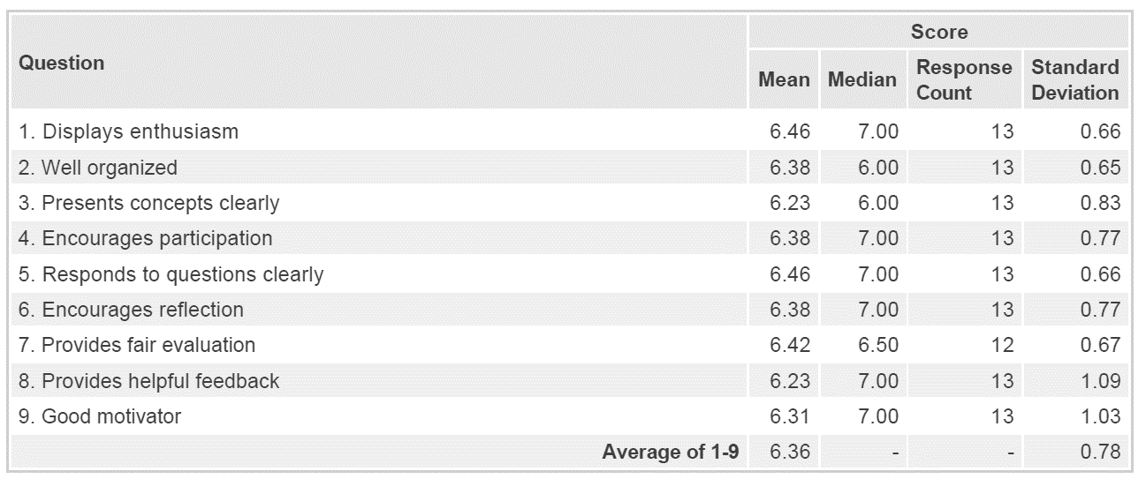

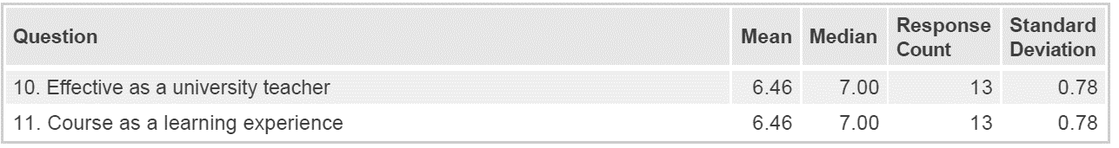

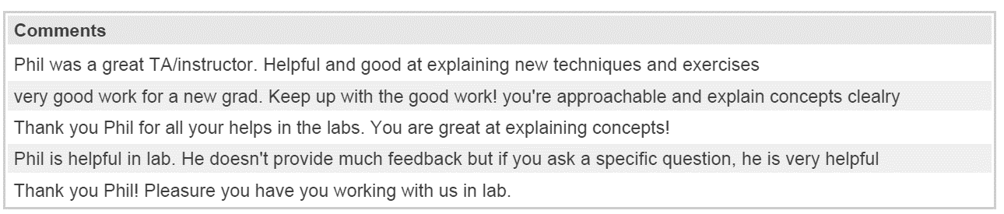

## Informal Student Evaluations:

Physiotherapy Student Clinical Instructor

*“I had a very positive experience working with Philemon as my clinical instructor at Form & Function Clinic. His patience, kindness, and understanding were evident in every encounter I had with him throughout my clinical experience, and I felt very comfortable approaching him with any questions or concerns I had. Philemon greatly facilitated my independent learning, directing me to evidence-based resources, and always taking the time to have thorough discussions with me. Philemon also emphasized the value of reflective practice, regularly engaged me to consider what aspects of my practice I did well as well as what I could improve upon in the future, as well as providing me with his thoughts and feedback on how I can improve. I strongly feel that, through my experiences with Philemon, I am much better equipped as a training practitioner, both for my future clinical placements and post-registration.”*

Clinical Intern Supervisor

*“I have had the pleasure of having Philemon as my mentor throughout my clinical internship at Form & Function. As an undergraduate student interested in pursuing physiotherapy, Philemon was always happy to answer any questions I had regarding the profession and treatments I shadowed, further solidifying my interest in the field. In addition to Philemon's receptiveness and patience, I appreciated how he made shadowing an interactive learning experience for me and my co-interns by quizzing us on concepts during his treatment sessions, including, but not limited to, anatomy, movement terminology and muscle contraction phases. Further, his expertise as a clinician-scientist shines through when reassuring his patients and educating them about their conditions, by using literature to address concerns and demystify any misconceptions. Philemon has also gone the extra mile in showing his passion for teaching and research by forwarding up-to-date scientific articles/videos to me and my co-interns, complementing what he has taught us in the clinic. I will miss learning from Philemon and am immensely grateful for what he has taught me during these last four months! I wish him nothing but continued success as he evolves his career!”*

*“Throughout the past few months that I’ve been at Form & Function’s internship program, I have learned so many new things through shadowing Philemon. He is very passionate and patient when teaching. Philemon explains concepts thoroughly while bringing in examples and literature to further explain the ideas. While teaching, he also asks questions to test our knowledge, relating to muscle terminology, different parts of the skeletal and muscular systems, and more. Philemon’s positivity and encouraging personality made my internship experience very rewarding. He truly is an excellent and caring mentor. I wish Philemon the best with his career!”*

Limited Duties Instructor (Clinical Associate)

*“I had the opportunity to have Phil not only as a Clinical Associate at Western but as well as a colleague of mine at my clinical placement at Family Physiotherapy Center of London. In both settings, Phil was a very considerate and thoughtful individual who always took time to check in on my year’s classmates on their understanding in our clinical labs, and myself at my placement to see if I needed any guidance. Despite, he was only a year above me in the program, he was an insightful mentor, willing to discuss both evidence based research and also empathize about the imposter syndrome and the uncertainty of transitioning into the “real world” as a new graduate. I am fortunate of my time spent with Phil.”*

# **Course Development**

## Course Design and Innovation

**PT 9527 and PT 9537, Clinics I and II:** With input from the course manager and another clinical associate, I developed class content that connected the knowledge of neuromusculoskeletal conditions to the assessment/diagnostic and treatment approaches. Clinics I and II involved the usage of online lectures and case discussions to learn foundational orthopedic physiotherapy knowledge. Lab sessions were facilitated by me and other instructors to apply the theoretical concepts. Community learning was also encouraged during open lab sessions. Further, I have been involved with the feedback and creation of a novel rubric to evaluate objective structured clinical exams (OSCE).

**Clinical Intern Protocol:** Building upon a previous intern and learning protocol, I developed a Clinical Intern protocol that suited the challenges of online platforms and learning. Furthermore, I integrated teaching and training on infection control into the protocol.

**Entry to Practice Essentials (EPE):** I was a content creator for EPE, an online preparation course designed to equip physiotherapy candidates for licensure. The content I created involved generating mock exam questions for the physiotherapy competency exam (PCE).

**Centennial College Math and Science Tutor:** I created an online module that students can access and utilize on their own time. This module used images and simple explanations to teach the concepts of molecules, atoms, and moles to students. As a math and science tutor, I noticed that these chemistry concepts were often more abstract and challenging for students to understand.

# **Professional Development**

Western Teaching Support Centre- Teaching in the Canadian Classroom (2015)

Teaching in the Canadian Classroom is a 16-hour short course designed for graduate students who would like to explore cultural differences in the classroom and gain confidence as a teaching assistant in the Canadian academic setting. We discussed common teaching topics, such as lesson planning, active learning, feedback, and classroom management, through a cross-cultural lens. I was able to gain hands-on experience by practicing instructional techniques in microteaching sessions where I received constructive feedback from peers and the instructor.

Monarch System- Applied Motivational Interviewing and Coaching (Level I) (2018)

The motivational interviewing workshop taught health professionals how to build motivation and transition that enhanced motivation into a strengthened and real commitment to an individual’s changed behaviours. Through this experience, I plan to use Motivational interviewing approaches to encourage student or mentee adherence and commitment. Students can express their own answers and plan of action for creating positive changes to their academic journey. This approach opens opportunities for students to have a high sense of self-efficacy over their own learning.